PÀ£ÁðlPÀ ¸ÀºÀPÁj ºÁ®Ä GvÁàzÀPÀgÀ ªÀÄºÁªÀÄAqÀ½ ¤AiÀÄ«ÄvÀ
PÀºÁªÀÄ ¸ÀAQÃtð, qÁ: JªÀiï.ºÉZï.ªÀÄjÃUËqÀ gÀ¸ÉÛ, ¨ÉAUÀ¼ÀÆgÀÄ – 560 029
¥ÉÆÃ£ï: 26096832 / 26096839/ 26096855 EªÉÄÃ¯ï: purchase@kmf.coop

¸ÀASÉå : PÀºÁªÀÄ/¥ÀDPÀªÀiÁ-546/2023-24 ¢£ÁAPÀ: 11-07-2023

E-¥ÉÆæÃPÉÆågÀªÉÄAmï ¥ÉÆÃlð¯ï ªÀÄÆ®PÀ PÀZÁÑªÀiÁUÀ¼À RjÃ¢UÁV PÀ£ÁðlPÀ ºÁ®Ä ªÀÄºÁªÀÄAqÀ½AiÀÄÄ e-Procurement GOK CrAiÀÄ°è ««zsÀ WÀlPÀUÀ½UÉ ªÉÆ¯Á¸À¸ï UÉæÃqï-J C£ÀÄß RjÃ¢¸ÀÄªÀ ¸ÀA§AzsÀ mÉAqÀgï DºÁé¤¹zÀÄÝ, D¸ÀQÛAiÀÄÄ¼Àî mÉAqÀgïzÁgÀgÀÄ ¨sÁUÀªÀ»¸À§ºÀÄzÁVzÉ. mÉAqÀgï zÁ¸ÁÛªÉÃdÄUÀ¼À£ÀÄß ºÁUÀÆ LlAªÁgÀÄ E.JA.r «ªÀgÀUÀ¼À£ÀÄß eProcurement website http://kppp.karnataka.gov.in ¤AzÀ qË£ï¯ÉÆÃqï ªÀiÁrPÉÆ¼Àî§ºÀÄzÁVzÉ.

C¯ÁàªÀ¢ü mÉAqÀgï ¥ÀæPÀluÉ (KMF/2022-23/IND0146)
PÀæ.¸ÀA | PÀZÁÑ ªÀiÁ®Ä | ¥ÀjªÀiÁt ªÉÄnæPï l£ïUÀ¼À°è (MT’s)
 |  | gÁeÁ£ÀÄPÀÄAmÉ | UÀÄ©â | zsÁgÀªÁqÀ | ºÁ¸À£À | ²PÁj¥ÀÄgÀ
01 | ªÉÆ¯Á¸À¸ï (UÉæÃqï-J) | 1500 | 1500 | 1000 | 3000 | 1000

mÉAqÀgï ªÉÃ¼Á¥ÀnÖ
mÉAqÀgï ¥ÁægÀA¨sÀªÁUÀÄªÀ ¢£ÁAPÀ | 12-07-2023
¥sÀÆªÀð ©qï ¸À¨sÉAiÀÄ ¢£ÁAPÀ | 15-07-2023 at 15:00 Hours
mÉAqÀgïzÁgÀgÀÄ ªÁtÂdå zÀgÀUÀ¼À£ÀÄß £ÀªÀÄÆ¢¸À®Ä PÉÆ£ÉAiÀÄ ¢£ÁAPÀ | 19-07-2023 at 15:00 Hours
vÁAwæPÀ ©qïUÀ¼À£ÀÄß vÉgÉAiÀÄÄªÀ ¢£ÁAPÀ | 20-07-2023 at 15:05 Hours
ªÁtÂdå mÉAqÀgïUÀ¼À£ÀÄß vÉgÉAiÀÄÄªÀ ¢£ÁAPÀ | 21-07-2023 at 15:15 Hours

PÀ£ÁðlPÀ ºÁ®Ä ªÀÄºÁªÀÄAqÀ½AiÀÄ ¥ÀgÀªÁV
¸À»/-
¤zÉðÃ±ÀPÀgÀÄ (RjÃ¢)

KARNATAKA COOPERATIVE MILK PRODUCERS' FEDERATION LIMITED
KMF COMPLEX, DR.M.H MARIGOWDA ROAD, BANGALORE-29.
Tel: 26096832 / 26096839/ 26096855, Email: purchase@kmf.coop
GST No.29AAAAK1110G4Z4
--------------------------------------------------------------------------------------------------------------------------------------------------------------------
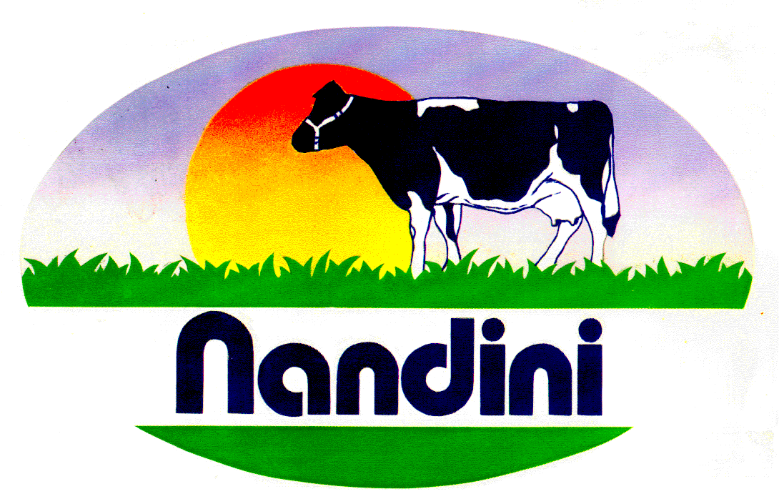IFT No. KMF/CFRM-546/2023-24 Date: 11-07-2023

SHORT TERM TENDER NOTIFICATION
(Through e-Procurement Portal GOK Only)
E-procurement GOK Indent No. KMF/2022-23/IND0146
The Karnataka Milk Federation invites Tenders from eligible Tenderers for supply of following Raw Material as stipulated below.

Sl No | Raw material | Total Qty. in MT
 |  | Rajanukunte | Gubbi | Dharwad | Hassan | Shikaripura
1 | Molasses (Grade -A) | 1500 | 1500 | 1000 | 3000 | 1000

Tender documents along with EMD details may be downloaded from e-Procurement website https://kppp.karnataka.gov.in Interested tenderers participate in the tender by logging on the website https://kppp.karnataka.gov.in Also may contact Help line No: 080-46010000 / 080-68948777 Email: support@eprochelpdesk.com. Tender Notification will be uploaded at KMF website. www.kmfnandini.coop

Tender Schedule :
Date of Commencement of Tender | 12-07-2023
Pre Bid Meeting | 15-07-2023 at 15:00 Hours
Last date for submission of Tender | 19-07-2023 at 15:00 Hours
Date of opening Technical Tender | 20-07-2023 at 15:05 Hours
Date of opening Commercial Tender | 21-07-2023 at 15:15 Hours

For KARNATAKA MILK FEDERATION LTD,
Sd/-

DIRECTOR (PURCHASE).

